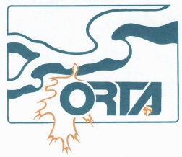
ORTA EXPENSE REPORT P.O. Box 28544
(Attach receipts. Not required on claims for kilometrage) 6

Print Name:
GL CODE  OFFICE USE ONLY | DATE: | MAIN CATEGORY:  Board, Exec., Trail, Training, Adv.Relay,  Discovery Night,  Admin., P.R. | PARTICULARS or  SUB-CATEGORIES:  Travel, Parking, Meal, Event, Postage, Printing, Sign, Tools, Gas, Maint., | KILOMETRAGE  TOTAL KM @ $0.61 |  | AMOUNT  ($)
 |  |  |  |  | @.61
 |  |  |  |  | @.61
DATE: |  |  | REIMBURSEMENT TOTAL: |  |  | $
SCOTIACONNECT REF# |  |  | APPROVED BY:
ACCOUNTING: |  |  | APPROVED DATE:
GST/HST NET:
Chapter:
Date Submitted: Signature:

